**An Overview on the Brazilian Digital Payment System: Legal, Business and Technological Aspects**

**Abstract**

The adoption of new, digital payment methods brings significant benefits to customers and society such as improved efficiency, greater competition, broader financial inclusion, and more innovation, according to IMF in *Digital Currencies: The Rise of Stablecoins*, 2019. The digital payment market is a $3 trillion industry, corresponding to 13% of total commerce, and will more than double by 2022, informs the McKinsey report *Global payments 2018: A dynamic industry continues to break new ground*, 2018. Although it is a prospective market, the Digital Payment System (DPS) is not an intensive research topic, with a literature still in an embryonic stage. Even more: it does not completely capture the real movement on DPSs happening worldwide. Through an extensive but not exhaustive *overview* on the Brazilian DPS, in the domain of *mixed methodology research*, this paper aims to develop the literature on the field, mainly but not exclusively focused on the *business* and *technology* fronts; to partially fulfill the gap between market and academia, through a comprehensive analysis on usual KPIs and descriptive statistics on DPSs, establishing a parallel with recent literature; and, finally, to describe challenges and opportunities for development in the DPS both in market and academia. There are two main research questions: (1) “What is the current status of the DPS in Brazil, from the legal, business and technological aspects?”, which has formulated the hypothesis that “there is moderate development of the DPS, due in large part to technological advancements, but insignificant legal measures to foster innovation in this market and respond to the rising challenges”, rejected under our research and observation; (2) “What are the main topics and issues for the further development of research in this novel field?”, generating the hypothesis that “the main topics on Brazilian DPS concern on (a) barriers to further development of the market posed by lack of technological advancement and (b) improvement of legal responses to the phenomenon”; partially accepted and non-confirmed, respectively to (a) and (b), under our research and observation. Our results show that: (1) all recent papers on the theme converge: *attitude*, *personal innovation in IT*, *perceived usefulness*, *perceived security* and related were the main findings as determinants of actual and future intention to use *m-payment* and novel technology for payments in Brazil; (2) *regulation* and *technology* play a major role for companies that need to adequate themselves to rules and good practices still under development; (3) the Brazilian DPS is a mix of elements in the well-placed North American Payment System with some incipient and novel aspects of the Chinese Payment System, with proper characteristics from Brazilian regulation, consumer profile and socioeconomic outlook, turning it into a unique landscape.

**Keywords**

Digital Payment Systems, the Brazilian Digital Payment System, Overview

**Panorama sobre o Mercado Digital de Pagamentos Brasileiro**

**Resumo**

A adoção de novos meios de pagamento digitais traz benefícios significativos aos consumidores e à sociedade, tal como aumento da eficiência e competição, inclusão e expansão do mercado financeiro, e mais inovação, de acordo com o IMF em *Digital Currencies: The Rise of Stablecoins*, 2019. O mercado de pagamentos digitais é uma indústria de U$ 3.0 trilhões, correspondendo por 13% do comércio mundial, e mais do que dobrará de tamanho até 2022, informa a *McKinsey report Global payments* 2018: *A dynamic industry continues to break new ground*, 2018. Embora seja um mercado com boas perspectivas, o Sistema de Pagamentos Digitais (SPD) não é um tema de pesquisa em foco na academia, com uma literatura ainda em estado embrionário, de tal modo que não captura a tendência atual no mercado mundial. Através de um panorama extenso, no domínio da *metodologia de pesquisa mista*, mas não-exaustivo, esse artigo busca: desenvolver a literatura na área majoritariamente, mas não exclusivamente, focando nas frentes de *tecnologia* e *negócios*; nivelar mercado e academia, através de uma análise compreensiva de KPIs usuais e estatísticas descritivas, estabelecendo um paralelo com a literatura recente em SPD; e, finalmente, descrever os desafios e oportunidades para o desenvolvimento do SPD tanto no mercado quanto na academia.

**Palavras-Chave**

Sistema de Pagamentos Digitais, Sistema de Pagamentos Digitais Brasileiro, Panorama

**1. Introduction: The Digital Payment System**

The digital payment market, defined as *all consumer remote point-of-sale transactions through online or mobile channels, including retail ecommerce and digital travel but excluding in-store digital wallet*s, is a $3 trillion industry, corresponding to 13% of total commerce, and one that will more than double by 2022 (MCKINSEY, 2018). Asia-Pacific comprises 50% of this $3 trillion and, due to the fast-growing Chinese market, will increase its share to nearly 70% by 2022 (MCKINSEY, 2019). *Mobile commerce*, including in-app payments and mobile browser payments, is the dominant factor driving strong digital commerce growth – due to rising smartphone adoption, an increasing shift towards online shopping, and improvements in network bandwidth – accounting for 48% of digital commerce sales globally as of 2017, forecasted to reach 70% by 2022 (tripling to $4.6 trillion). The retail industry follows the same path (RESEARCH AND MARKETS, 2019).

The **mobile payment market** has started in the first payment transaction conducted with a mobile device in 1997 when, in Finland, Coca Cola experimented vending machines that accepted SMS payments (DAHLBERG, GUO & ONDRUS, 2015). Since then, the digital-payment landscape is growing in a fast pace and has become crowded (KAZAN & DAMSGAARD, 2016): “New payment actors with different industry backgrounds and novice start-ups are attempting to gain a foothold in the once-protected payment market. In doing so, new payment actors are betting on various technologies to connect payers and payees in novel ways. These new dynamics in the payment market are largely driven by falling operating costs, as new payment actors leverage on agile and affordable cloud systems, but, more importantly, by regulation. (…) To illustrate the competitive market space, *AngelList* (EUROPEAN COMISSION, 2009) listed about 996 U.S. and European mobile payment start-ups *without* including established actors such as *MasterCard*, *PayPal* or *Visa*.”

The **mobile payment research** has started just after the Coca Cola experience, with (DAHLBERG, GUO & ONDRUS, 2015), (OZCAN & SANTOS, 2015) and (HENNINGSSON & HEDMAN, 2015) established as seminal papers in the last decade. According to (DAHLBERG, GUO & ONDRUS, 2015)**, the mobile payment research received a considerable number of publications** and focused mainly on two issues since its inception: *technology* and *consumer adoption*, while several studies continuously show that *security* and *trust* are important prerequisites for the adoption and use of mobile payments.

The **Brazilian mobile payment research** has not developed as others worldwide: “*the recent and relevant literature in the Brazilian Digital Payment System, and how it is dealing with recent advances, is still in the embryonic stage. Significant articles on the field are rare*” (BRAGA, ISABELLA & CORREIO, 2019), considering also the lack of articles, *benchmarks* and algorithms that could be considered *state-of-the-art*. The existing works have their own merit, although it does not completely capture the real movement on digital payments systems happening worldwide.

Such limitations outlined the need of a work, nonexistent by now, that could offer a broad vision on the Brazilian DPS, an *overview*, considering legal, management, business, researcher aspects, between others. Through an extensive but not exhaustive *overview* on the Brazilian DPS, in the domain of *mixed methodology research*, which integrates both *qualitative* and *quantitative* research providing a holistic approach through combination and analysis of statistical data with deeper contextualized insights (UNIVERSITY OF NEWCASTLE, 2020), this paper aims to develop the literature on the field, mainly but not exclusively focused on the *business* and *technology* fronts; to partially fulfil the gap between market and academia, through a comprehensive analysis on usual KPIs and descriptive statistics on DPSs, establishing a parallel with recent literature; and, finally, to describe challenges and opportunities for development in the DPS both in market and academia, outlining major unanswered questions on the theme, still under covered in the research community.

Mixing articles focusing on *developing* and *developed* markets can cause confusion about the progress of mobile payment research, because mobile payment services from developing markets are unlikely to penetrate developed economies with their advanced financial markets and sophisticated telecom, merchant and consumer infrastructures (DAHLBERG, GUO & ONDRUS, 2015). This is the reason DAHLBERG, GUO & ONDRUS, 2015, prefer to avoid the inclusion of both types of markets into their review and solely focus on developed economies. In this paper, we follow the same criteria: we do not mix developing and developed markets; actually, we exclusively focus on the developing *Brazilian* one.

Two main research questions guide this paper: (1) “What is the current status of the DPS in Brazil, from the legal, business and technological aspects?”, which has formulated the hypothesis that “there is moderate development of the DPS, due in large part to technological advancements, but insignificant legal measures to foster innovation in this market and respond to the rising challenges”; (2) “What are the main topics and issues for the further development of research in this novel field?”, generating the hypothesis that “the main topics on Brazilian DPS concern on (a) barriers to further development of the market posed by lack of technological advancement and (b) improvement of legal responses to the phenomenon”.

This *overview* paper is structured as follows: chapter 2 shows the methodology used through the research; chapter 3 presents the Brazilian DPS, more specifically its legal landscape, the market itself with most relevant KPIs and quantitative estimates, besides major research papers regarding the theme; chapter 4 contemplates major perspectives for the market, pointing out the great historical moment for the DPS worldwide; chapter 5 concludes the paper, with possible paths for future work.

**2. Methodology**

The *mixed methodology research* is the one used in this article: “*Mixed methods research means adopting a research strategy employing more than one type of research method. The methods may be a mix or qualitative and quantitative methods, a mix of quantitative methods or a mix of qualitative methods*” (BRANNEN, 2005); *mixed method research* employs both iterative and simultaneous quantitative and qualitative approaches to create a research outcome stronger than either method individually, enabling to explore more complex aspects and relations of the human and social world. “*In both quantitative and qualitative methods, concepts can be imprecise and open to interpretation. Qualitative research typically answers research questions that address* ***how*** *and* ***why*** *whereas quantitative research typically addresses* ***how often*** *and* ***how many****. (…) Whether qualitative to quantitative research is staged iteratively from one to the other or simultaneously, it seems clear to us that both methods can contribute to understanding accounting phenomena*” (MALINA, 2011).

In this article, quantitative tools used are graph analysis and descriptive statistics of KPIs (Key Performance Indicators), e.g. total transaction value in the Digital Payments segment, its’ Compound Annual Growth Rate (CAGR), number of users in both mobile payments and digital commerce, and percentage of users distributed by age range and income status. Qualitative tools used are *record keeping*, *qualitative data collection*, and *qualitative data analysis* (BHAT, 2020), among others.

**3. The Brazilian Digital Payment System**

**3.1. Regulation**

*Banco Central do Brasil* (BACEN, or BCB) is the monetary, regulatory and supervisory authority which regulates financial institutions, money, credit, payments and exchanges, in accordance to guidelines issued by the *Conselho Monetário Nacional* (CMN) (BACEN, 2019), (THE LAW REVIEWS, 2019). Payment services are subject to the rules regarding the *Sistema de Pagamentos Brasileiro* (SPB), created by Law No. 10.214/01 (PLANALTO, 2001), and other entities of the *Sistema Financeiro Nacional* (SFN) such as the BCB and the *Comissão de Valores Mobiliários* (CVM) which also regulate their operations.

The year of 2018 was relevant to the payment market, as BACEN introduced provisions expected to innovate and promote financial inclusion and a more competitive market. By means of Resolution No. 4,707 and Circular No. 3,924, both of 19 December 2018, BACEN governs the use of payment arrangement receivables as collateral for credit transactions. On Circular No. 3,925 of 20 December 2018, which amended the Annex to Circular No. 3.682 as of 4 November 2013, BACEN addresses the provision of payment services within the framework of the arrangements of the SPB, establishing guidelines and standardizing the service providers need to abide by (THE LAW REVIEWS, 2019).

BACEN has continued its acts by establishing a working group with the objective of contributing to the construction of a competitive, efficient, safe and inclusive instant payments ecosystem. The working group helped the Board of Governors to determine an ecosystem guideline to the actual payment system. Around 130 institutions, including associations, banking institutions, payment schemes owners, credit unions, government institutions, financial market infrastructures, *fintechs*, marketplaces, consultancies and law offices took part in the discussions. The group finished the work by 21 December 2018, with the announcement of the *Communiqué 32,927* and the final version of the guidelines. BACEN, in line with other central banks, took the role of implementation leader and catalyst of the instant payments ecosystem in Brazil, with broad discussion with stakeholders, aiming at the definition of guidelines and other relevant matters (BACEN, 2019). For a rigorous analysis of the Brazilian payment market and mainly feasible proposals for the payment system regulation, see (FGV, 2019).

According to *Communiqué No. 32,927*, 21 December 2018, BACEN recognizes instant payments as valid and addresses the fundamental requirements for its environment within the Brazilian payment system regulatory framework. This enables the inclusion of new players in the financial market, which is of extreme significance in a country with high rates of banking concentration. The most important concern is that regulation in Brazil will respect permissionless innovation as a default (THIERER, 2016), in a productive interaction that will not completely stifle innovation while attempting to provide security. Regulatory sandboxes are a viable tool to achieve such a goal (FENWICK et al, 2017) and this strategy is being considered by the CVM. In September 2019, it issued a call for a public consultation on draft regulation that would institute rules for the functioning of such a sandbox encompassing temporary authorizations for companies to test novel business models in the Brazilian capital market.

**3.2. The Market**

Figures 1 to 8 (STATISTA, 2019) provides recent historical data and perspectives for the Brazilian DPS.

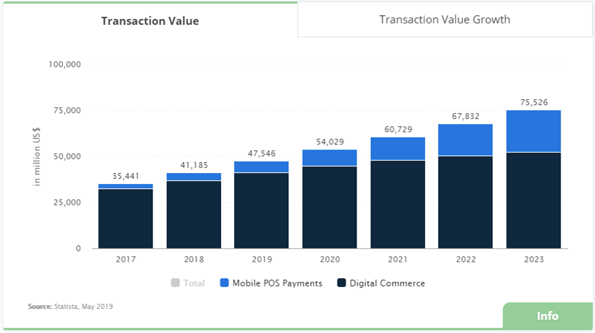

**Figure 1**: Total Transaction Value in the Digital Payment segment amounts to US$47,546 million in 2019.

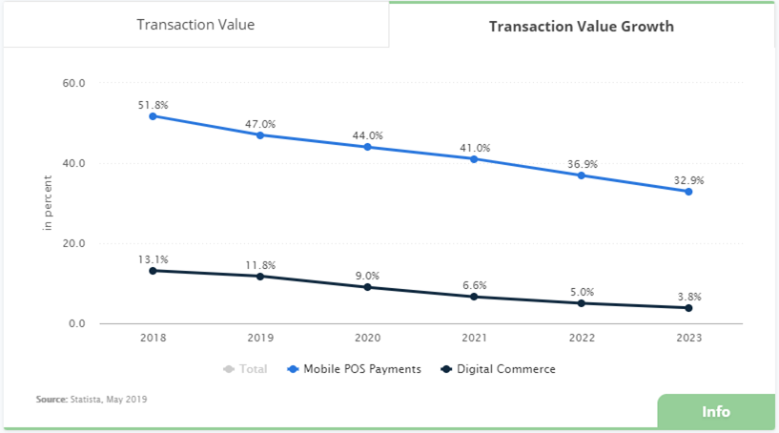

**Figure 2**: The Mobile POS Payment segment is expected to show a transaction value growth of 44.0% in 2020.

The total transaction value in the Digital Payments segment amounts to US$47,546 million in 2019, with a Compound Annual Growth Rate (CAGR) of 12.3% from 2019 to 2023, resulting in a perspective of US$75,526 million by 2023. The market's largest segment is Digital Commerce with a total transaction value of US$41,249 million in 2019, although Mobile POS Payments segment is expected to grow at a higher rate than the first, and both taxes of growth are expected to decrease as years go by.

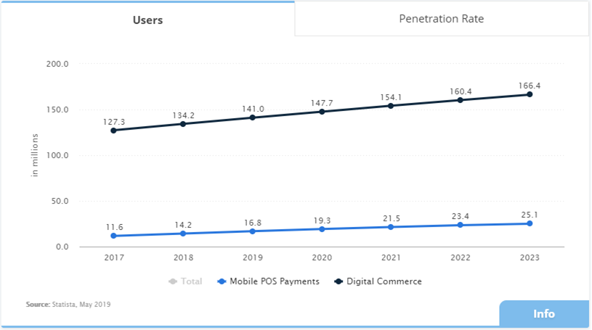

**Figure 3**: In the Mobile POS Payment segment, the number of users is expected to amount to 25.1 million by 2023.

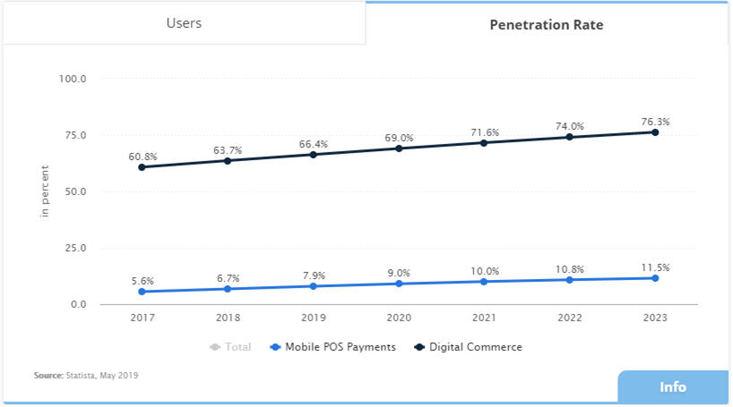

**Figure 4**: User penetration in the Digital Payment segment is at 66.4% in 2019.

Number of users in both Mobile POS Payments and Digital Commerce are expected to grow in an approximately linear pace, although the rate of change for the latter is slightly higher than the same measure for the former.

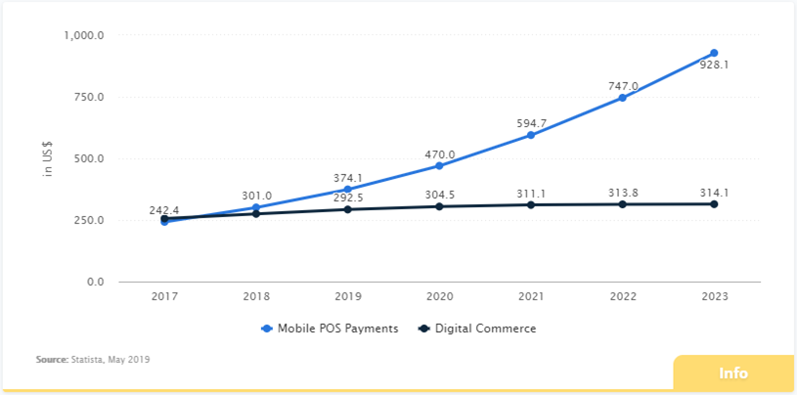

**Figure 5**: The average transaction value per user in the Mobile POS Payments segment amounts to US$374.1 in 2019.

There is a perspective of detachment for the Mobile POS Payments and Digital Commerce segments. As we will show in the following sections, this effect is potentially influenced by the Chinese retail payment revolution occurred in the last decade.

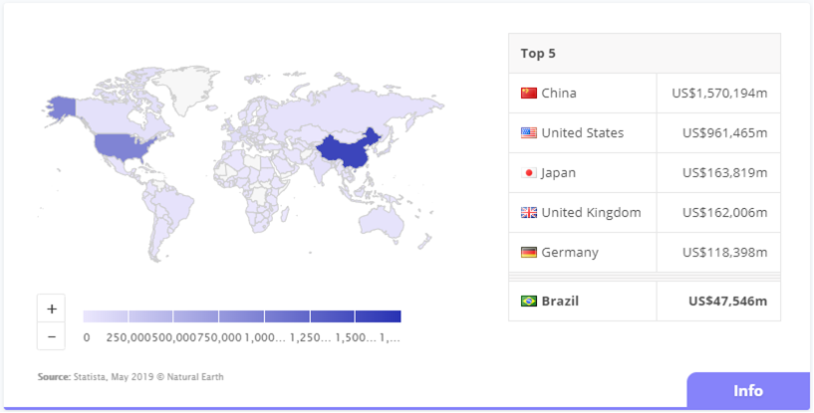

**Figure 6**: With a total transaction value of US$1,570,194 million in 2019, China reaches the highest value worldwide. Brazil scores US$47,546 million.

From a global comparison perspective, it is shown that the highest cumulated transaction value is reached in China (US$1,570,194 million in 2019), with Brazil figuring apart from the leaders.

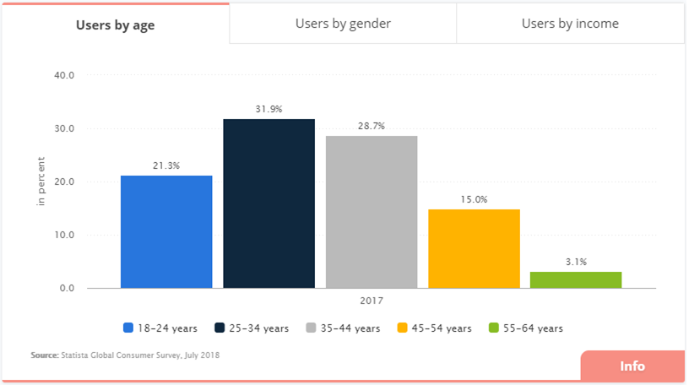

**Figure 7**: In 2017, 31.9% of users are in the 25-34 years old range.

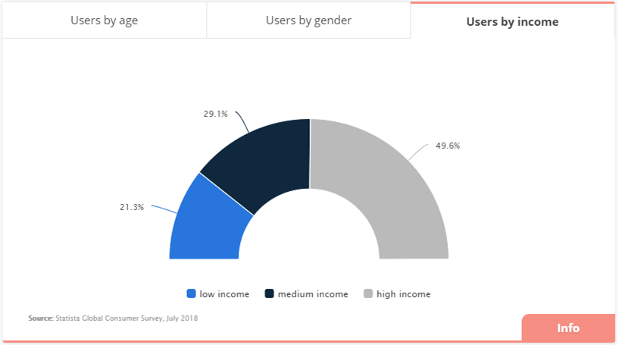

**Figure 8**: In 2017, 49.6% of users are settled in the high income category.

Figures 7 and 8 show histograms for percentage of users distributed by age range and income status, respectively. All information presented in this sub-session is relevant for the majority of analysis that one could be interested in: financial, marketing, and more. For our purpose, an *overview* of the Brazilian DPS, the previous analysis and conclusion is sufficient: *perspectives for the market are of straightforward growth*.

**3.3. Literature**

“*The recent and relevant literature in the Brazilian Digital Payment System, and how it is dealing with recent advances, is still in the embryonic stage. Significant articles on the field are rare*” (BRAGA, ISABELLA & CORREIO, 2019). This is completely understandable, since the ecosystem of mobile payments requires the creation of accords between various players and it is essential to develop interest and synergy between banks, technology businesses, credit card companies, telephone services, startups, governments, businesses, customers and other stakeholders – the context Brazil is facing now. BACEN’s initiative aims to ground that landscape.

In the following section, we highlight and discuss major recent works in the Brazilian Payment System and Market, without exhausting the literature. The focus is on their contribution and possible suggestions for improving the system and market, mainly using models and methods to identify most relevant variables.

**3.3.1. *NFC technology acceptance for mobile payments: A Brazilian Perspective*, 2018** (LUNA et al, 2017)

It investigates the acceptance of NFC (Near Field Communication) technology for payment through mobile in a Brazilian context, allowing to infer factors that influence NFC acceptance directly or indirectly. They have decided the need to study mobile payments in Brazil by comparing the number of credit/debit cards with the number of mobile phones in developed and developing countries, observing a larger amount of credit/debit cards than mobile phones in developed countries, and the opposite in developing ones.

Through an online and self-administered questionnaire and using the snowball sampling procedure on social networks, a final sample with 423 mobile phone users in Brazil was collected and used. The technique used to prove the hypothesis was the *Structural Equation Model* (SEM), a generalist statistical modeling technique widely used in the behavioral sciences, composed by a combination of factor analysis and econometrics (REFERENCE, 2017). Results show that *attitude*, *personal innovation in IT* and *perceived usefulness* are determinants of future intention to use the NFC technology for payments in Brazil. The proposed model has a predictive power of intention to use NFC payment of 71%, demonstrating that it includes background with a large predictive power of acceptance of NFC technology which led to highlight the main implications for the management and development of new studies in the field. The authors state that there were no specific studies on NFC’s acceptance in Brazil by the time of their work and, for this reason, their contribution is relevant for both Brazilian academia and the mobile industry.

The study also cites authors that consider the subject is still in its infancy (e.g., (SLADE, WILLIAMS & DWIVDEI, 2013), (LIÉBANA-CABANILLAS, LUNA & MONTORO-RÍOS, 2015)), despite the significant advances in recent years in this field (e.g., (DAHLBERG, GUO & ONDRUS, 2015)).

**3.3.2. *Digital Payment Means: The Brazilian reality. An "Environmental Segmentation" Study*, 2019** (BRAGA, ISABELLA & CORREIO, 2019)

Through the environmental segmentation model of (ALMEIDA, 2001), this work aims to present the main factors necessary for the viability of the use and expansion of digital payment means in Brazil, using a qualitative exploratory research (including interviews with experts in the field) on electronic and digital payment case studies. The authors conclude that digital payments will bring gains in *efficiency* and *security*, as well as a reduction in cash maintenance costs and, perhaps more importantly, the rise of new markets and new services. However, they point to obstacles such as lack of specific regulation, technology to more securely identify users, high hardware costs, digital infrastructure bottlenecks “and conflicts of interest among the main players in the segment”. Another study focused on e-commerce and digital payments in Brazil had similar findings regarding security as a deterrent (MOREIRA, 2016).

**3.3.3. *Predicting the determinants of mobile payment acceptance: A hybrid*** ***SEM-neural network approach*, 2018**(LIÉBANA-CABANILLAS, 2018)

It develops a new research model to predict the most significant factors influencing the decision to use *m-payment* (mobile payment), using an online survey of a national panel of smartphones users, through two sequential techniques: *Structural Equation Modeling*, used to determine which variables had significant influence on mobile payment adoption, and a neural network model to rank the relative influence of significant predictors obtained by SEM. It has been found that the most significant variables impacting the intention to use m-payment were *perceived usefulness* and *perceived security variables*. On the other side, the results of neural network analysis confirmed many SEM findings, but also gave slightly different order of influence of significant predictors. Although the dataset is composed by Spanish users, many elements of this research are highly applicable to Brazilian market.

Complementing the ideas discussed in the papers above, which are highly contemporary and have their own merit, the next section will approach some perspectives for the Brazilian DPS, focusing on its nature in comparison with counterparts worldwide.

**4. Perspectives**

Data from 2018 shows that 49% of Brazilian internet users use only their smartphones to access the internet, while 47% combine smartphones and desktop, laptop, tablets and other devices to do so. This is the first time the former category surpasses the last (GLOBO, 2018). If discriminated by social category, *Smartphone Internet* *Access* type (SIA) is even bigger for Brazilian classes D and E than for A, B and C together, with *pre-payed* type connections representing 70% of the total. From one way or another, Brazilian numbers are greater than the global average: 39% of people in the world use SIA. Regarding the time spent online, Brazil is 3rd worldwide: Brazilian internet users spend 9 hours and 14 minutes by day, on average, with more than 30% of this time dedicated to social networks, a share surpassed by one country only. Thailand (9 hours and 38 minutes) and Philippines (9 hours and 24 minutes) are the world leaders. Cellphone/smartphone average penetration, i.e. the number of devices *per capita*, is close to 68% worldwide, a number also observed in Brazil (GLOBO, 2018).

Contradictorily, Brazil is below the average when the topic is the proportion of the population that buys online: only 45% of Brazilians, compared to a global average of more than 50%, with global leaders like United Kingdom, South Korea, Germany, Sweden and USA scoring 78%, 74%, 74%, 69% and 69%, respectively (TILT, 2018), (DATAREPORTAL, 2019). From 2013 to 2018, a BACEN report shows just a little difference in the form that Brazilian commercial institutions receive payments: cash, debit and credit cards accounted for 96% of payments in 2013; in 2018, the proportion went up to 98% (INFOMONEY, 2019), (BACEN, 2018). In the rest of the world, the situation is just the opposite: in 2018, less than 1% of transactions were made with cash in Sweden; in China, more than 90% of payments are made using two *apps* (*WeChat* and *Alipay*) nowadays, with more than 50% of the money generated by commercial payments in the country (QUARTZ, 2019).

**With all those numbers, the following question arises naturally**: *Why do not Brazilians largely use digital payment devices*? The country is one of the leaders in *hours-online* and also on social media, in smartphone use and follows the world average on cellphone/smartphone average penetration.

To answer the former question is quite challenging: hundreds, maybe thousands of variables could be considered to model this, apart from the type of possible approaches, and this article will not follow this path. Instead, it is reasonable to ask: *How is the Brazilian system compared to other major payment systems in the world*?

This following section is almost entirely based on (BROOKINGS, 2019).

**4.1. The North American and the Chinese Payment System**

50 years ago, the USA led a global revolution with the creation of magnetic striped cards linked to bank accounts and lines of credit, allowing a small plastic card to replace cash and checkbooks for billions of consumers and merchants, processing trillions of transactions. This system has continued to grow, providing the backbone for *e-commerce* and new methods of *m-payments*. Devices can now turn smartphones into credit card processors and transactions can be securely transacted online (e.g. *Paypal*). **However, the underlying payment networks in America remain a bank-based system**, where the payment and banking systems have been intertwined for centuries.

While the USA spent the past decade upgrading its bank-based magnetic striped cards with chips, China experienced a retail payment revolution. Running away from the card-based landscape, two new payment systems now dominate person-to-person, retail, and many business transactions. It is built on Digital Wallets (DW), QR (Quick Response) codes, and runs through their own big tech firms: *Alipay*, running through *Alibaba* (China’s version of *Amazon*), and *WeChat Pay*, running through *Tencent* (China’s version of *Facebook***)**, counting for more than 1 billion users each. **China has performed something far beyond the creation of a new technological form of payment: it has largely disintermediated the banking system**, taking away from it an important and long-standing source of revenue. Other digital platforms such as fintechs that operate as P2P lending marketplaces are also “instruments for financial disintermediation” that operate in a very different way from banks: “digital platforms are ‘transparent’ intermediaries between borrowers and investors, while banks are ‘opaque’ intermediaries that extend credits to clients on their own books, while receiving deposits from savers as liabilities.” (FERRARINI, 2017: 124).

**4.2. Is there a trend in place?**

“Is QR (Quick Response) code the new card?” Payments using QR codes dismiss cards or money, using just a smartphone, for example, and can also be associated with a company which DW allows a recharge by a payment bill, something that directly affects more than 45 million Brazilians (22% of the total population) that do not have or trade bank accounts (EXAME, 2019). In 2019, the study “*Novos Meios de Pagamento*” listened to 500 people from distinct age groups, income ranges and geographic regions in Brazil, attesting that 17% of consumers are now using QR code for payments in retail stores, while the same quantity was 0% in 2018. But money, credit card and debit card are still the leaders in preference for payments in retail stores: percentages are 68%, 62% and 54%, respectively, while payments using apps, like *Samsung Pay* and *Apple Pay*, account for 24% (SBVC, 2019). Users also affirmed that QR codes and apps are the digital payment method they would most like to use (17% and 20%, respectively), but they do not do so because most commerce vendors do not accept them.

**4.3. Challenges**

“*Through the process of improving payments by QR code, one of the challenges is exactly the user education*”, according to Daniel Bergman, CEO of *Movile Pay*, one of the companies that hosts DW and QR codes, a method that does not stop growing and has become a major problem in Brazil, as there is no unique system for hosting all the DWs and making them iterate and recognize each other. *Cielo*, the largest Brazilian credit and debit card operator and the biggest payment system company in Latin America by revenue and market value, recently started a partnership with *PicPay* (the biggest DW in Brazil, with 10 million users), but it’s QR code is also accepted in dozens of DWs, like *BanQi* (from *Via Varejo*) and *Next* (from *Bradesco*). *GetNet* (from *Santander*), *Stone*, *PagSeguro*, *Mercado Livre* and *Itaú* bank also offers QR codes (EXAME, 2019). There is evidence that some Brazilian banks perform poorly in the transition to digital and it would be important for them to invest on digital transactions in order to improve (CARAFFINI et al, 2018).

**5. Conclusion**

The two main research questions were answered by our findings, by structuring the current status of the digital payment market in Brazil, from the legal, business and technological aspects, and by approaching the main topics and issues for the further development of research in the field. The hypothesis “there is moderate development of the DPS, due in large part to technological advancements, but insignificant legal measures to foster innovation in this market and respond to the rising challenges” was rejected under our research and observation, due the fact that the market is currently more developed as the authors previously conjectured, and legal answers to the main topics approached on this paper are not a relevant problem. The hypothesis “the main topics on Brazilian DPS concern on (a) barriers to further development of the market posed by lack of technological advancement and (b) improvement of legal responses to the phenomenon” was partially accepted and non-confirmed, respectively to (a) and (b), under our research and observation, due the fact: (a) technology is not a relevant barrier in the Brazilian DPS, in fact the country is one of the leaders in hours-online and social media, in smartphone use and follows the world average on cellphone/smartphone average penetration, theoretically allowing a much more advanced DPS; (b) legal answers are not a relevant problem. This paper is also successful on fulfilling its objectives, giving an *overview* on the Brazilian DPS and certainly developing the literature on the field. The topics of *regulation* and *technology* play a major role, as companies need to adequate themselves to rules and good practices that are still under development, e.g. the way consumers and vendors will manage dozens of DW and QR codes payment options. A similar issue happened in the past, when BACEN had to intervene in the *payment machines* market. Until 2010, *Cielo* (former *Visanet*) and *Rede* (former *Redecard*), controlled the market, requiring exclusivity from vendors. BACEN disabled the duopoly, promoting an open market with more competitors (EXAME, 2019). Thus, the DW standardization is already a theme of discussion and a natural topic to be developed in both market and academia. An *econometric* approach is also viable for future work, aiming to understand how relevant variables quantitatively affect one or more variables of interest, as in (NELSON & PLOSSER, 1982), (CAMPBELL & MANKIW, 1987) and (DAVIDSON & MACKINNON, 1993).

Some recent papers on the Brazilian DPS were analyzed and they all converge: *attitude*, *personal innovation in IT*, *perceived usefulness*, *perceived security* and related were the main findings as determinants of actual and future intention to use *m-payment* and novel technology for payments in Brazil. The question “*why do not Brazilians largely use digital payment devices*?” is still in place. The country is one of the leaders in *hours online* and on social media, in smartphone use and follows the world average on cellphone/smartphone average penetration, thus that fact is noteworthy for future research. Instead of answering the former question, we focused on “*how the Brazilian system is compared to other major payment systems in the world*?” We got some viable information about a landscape that is potentially a mix of elements in the well-placed North American Payment System with some incipient and novel aspects of the Chinese Payment System, structuring a unique Brazilian DPS, with proper characteristics from Brazilian regulation, consumer profile and socioeconomic outlook. Next steps on this direction will fully characterize the Brazilian DPS in terms of the Chinese and the North American one, stablishing a direct comparison.

**5. Bibliography**

ADI BHAT. Qualitative Research: Definition, Types, Methods And Examples. Disponível em: https://www.questionpro.com/blog/qualitative-research-methods/. Acesso em: 19 mar. 2020.

ALMEIDA, M. I. R. D. Manual de Planejamento Estratégico. 1. ed. Brasil: Atlas, 2001. p. 1-156.

BANCO CENTRAL DO BRASIL. About. Disponível em: https://www.bcb.gov.br/en/about. Access Date: 3 set. 2019.

BANCO CENTRAL DO BRASIL. O brasileiro e sua relação com o dinheiro - Pesquisa 2018. Disponível em: https://www.bcb.gov.br/content/cedulasemoedas/pesquisabrasileirodinheiro/Apresentacao_brasileiro_relacao_dinheiro_2018.pdf. Access Date: 4 out. 2019.

BRAGA, F. D. M. A. A; ISABELLA, Giuliana; CORREIO, H. R. R. Digital Payment Means: the Brazilian reality: An "Environmental Segmentation" study. Journal of Management of Roraima, Roraima, Brazil, v. 8, n. 1, p. 65-85, jun./2018. Disponível em: <https://www.researchgate.net/publication/329134551_Digital_Payment_Means_the_Brazilian_reality_An_Environmental_Segmentation_study>. Access Date: 27 ago. 2019.

BRANNEN, Julia. Mixed Methods Research: A discussion paper. ESRC National Centre for Research Methods, London, v. 5, n. 1, p. 1-30, dez./2005. Disponível em: <http://citeseerx.ist.psu.edu/viewdoc/summary?doi=10.1.1.468.360>. Acesso em: 19 mar. 2020.

BROOKINGS. Is China’s new payment system the future?. Disponível em: https://www.brookings.edu/wp-content/uploads/2019/05/ES_20190617_Klein_ChinaPayments.pdf. Access Date: 5 out. 2019.

CAMPBELL, John Y.; MANKIW, N. Gregory. Permanent and Transitory Components in Macroeconomic Fluctuations. NBER Working Paper No. 2169, Cambridge, Massachusetts, v. 77, n. 2, p. 111-117, fev./1987.

CARAFFINI, Josiane et al. Transformação Digital e Desempenho no Setor Bancário. Congresso Transformação Digital 2018. Available at: <http://bibliotecadigital.fgv.br/ocs/index.php/ctd/ctd2018/paper/viewFile/6965/1971>.

DAHLBERG, Tomi; GUO, Jie; ONDRUS, Jan. A critical review of mobile payment research. Electronic Commerce Research and Applications, Finland, v. 14, n. 5, p. 265-284, set./2015. Disponível em: <https://www.sciencedirect.com/science/article/pii/S156742231500054X>. Access Date: 22 ago. 2019.

DATAREPORTAL. DIGITAL 2019: BRAZIL. Disponível em: https://datareportal.com/reports/digital-2019-brazil?rq=brazil. Access Date: 3 out. 2019.

DAVIDSON, Russell; MACKINNON, James G.. Estimation and Inference in Econometrics. 1. ed. New York, NY: Oxford University Press, 1993. p. 1-896.

EUROPEAN COMISSION. Sustainability Report 2009 - EUROPEAN ECONOMY 9|2009. Disponível em: https://ec.europa.eu/economy_finance/publications/pages/publication15998_en.pdf. Access Date: 12 ago. 2019.

EXAME. Para além dos restaurantes, iFood coloca QR Code em bancas de jornal. Disponível em: https://exame.abril.com.br/negocios/para-alem-dos-restaurantes-ifood-coloca-qr-code-em-bancas-de-jornal/. Access Date: 5 out. 2019.

FENWICK, Mark. KAAL, Wulf A. VERMEULEN, Erik. Regulation Tomorrow: What Happens When Technology Is Faster than the Law. American University Business Law Review. v. 6, n. 3, 2017.

FERRARINI, Guido. Regulating FinTech: Crowdfunding and Beyond. European Economy. N. 2, 2017.

GLOBO.COM. Brasileiro é um dos campeões em tempo conectado na internet. Disponível em: https://g1.globo.com/especial-publicitario/em-movimento/noticia/2018/10/22/brasileiro-e-um-dos-campeoes-em-tempo-conectado-na-internet.ghtml. Access Date: 3 out. 2019.

HENNINGSSON, Stefan; HEDMAN, Jonas. The new normal: Market cooperation in the mobile payments ecosystem. Electronic Commerce Research and Applications, Copenhagen, v. 14, n. 5, p. 305-318, mar./2015. Disponível em: <https://research.cbs.dk/en/publications/the-new-normal-market-cooperation-in-the-mobile-payments-ecosyste>. Access Date: 16 ago. 2019.

HOX, Joop; BECHGER, Timo. An Introduction to Structural Equation Modeling. Family Science Review, Amsterdam, v. 11, n. 1, p. 354-373, fev./1998. Disponível em: <http://joophox.net/publist/semfamre.pdf>. Access Date: 14 nov. 2019.

INFOMONEY. A era do pagamento digital: a revolução na forma de se fazer compras. Disponível em: https://www.infomoney.com.br/colunistas/blog-do-cunha/a-era-do-pagamento-digital-a-revolucao-na-forma-de-se-fazer-compras/. Access Date: 30 set. 2019.

KAZAN, Erol; DAMSGAARD, Jan. Towards a Market Entry Framework for Digital Payment Platforms. Communications of the Association for Information Systems, Copenhagen, v. 38, n. 37, p. 761-783, mai./2016. Disponível em: <https://pdfs.semanticscholar.org/30d2/fdf921e1b66a31d47033c825435966bd5891.pdf>. Access Date: 21 ago. 2019.

LIÉBANA-CABANILLAS, F. et al. Predicting the determinants of mobile payment acceptance: A hybrid SEM-neural network approach. Technological Forecasting and Social Change, Granada, Spain, v. 129, n. 4, p. 117-130, abr./2018. Disponível em: <https://www.sciencedirect.com/science/article/pii/S0040162517301580?via%3Dihub>. Access Date: 28 ago. 2019.

LIÉBANA-CABANILLAS, Francisco; LUNA, I. R. D; MONTORO-RÍOS, Francisco J.. User behaviour in QR mobile payment system: the QR Payment Acceptance Model. Technology Analysis & Strategic Management, Granada, Spain, v. 27, n. 9, p. 1031-1049, jun./2015. Disponível em: <https://www.tandfonline.com/doi/full/10.1080/09537325.2015.1047757>. Access Date: 16 set. 2019.

LUNA, I. R. D. et al. NFC technology acceptance for mobile payments: A Brazilian Perspective. Revista Brasileira de Gestão de Negócios, Granada - Spain, v. 19, n. 63, p. 82-103, ago./2016.

MALINA, Mary A.; NORREKLIT, Hanne; SELTO, Frank H.. Lessons Learned: Advantages and Disadvantages of Mixed Methods Research. Qualitative Research in Accounting and Management, Emerald Group Publishing Limited, v. 8, n. 1, p. 59-71, mai./2011. Disponível em: <https://papers.ssrn.com/sol3/papers.cfm?abstract_id=1826304>. Acesso em: 19 mar. 2020.

MCKINSEY & COMPANY. Global payments 2018: A dynamic industry continues to break new ground. Disponível em: https://www.mckinsey.com/~/media/McKinsey/Industries/Financial%20Services/Our%20Insights/Global%20payments%20Expansive%20growth%20targeted%20opportunities/Global-payments-map-2018.ashx. Access Date: 1 set. 2019.

MCKINSEY & COMPANY. Global payments 2019: A dynamic industry continues to break new ground. Access Date: 1 set. 2019.

MOREIRA, Robson Antonio. COMÉRCIO ELETRÔNICO, OS MÉTODOS DE PAGAMENTOS E OS MECANISMOS DE SEGURANÇA. REFAS. v. 3, n. 1, 2016.

NELSON, Charles; PLOSSER, Charles. Trends and random walks in macroeconomic time series: Some evidence and implications. Journal of Monetary Economics, Washington, Seattle, v. 10, n. 2, p. 139-162, jul./1982. Disponível em: <http://schwert.ssb.rochester.edu/a425/jme82_NP.pdf>. Access Date: 12 set. 2019.

OZCAN, Pinar; SANTOS, Filipe M.. The market that never was: Turf wars and failed alliances in mobile payments. Strategic Management Journal, Warwick, Coventry, U.K, v. 36, n. 10, p. 1486-1512, mai./2014. Disponível em: <https://onlinelibrary.wiley.com/doi/full/10.1002/smj.2292>. Access Date: 14 ago. 2019.

PRESIDÊNCIA DA REPÚBLICA CASA CIVIL SUBCHEFIA PARA ASSUNTOS JURÍDICOS. LEI No 10.214, DE 27 DE MARÇO DE 2001. Disponível em: http://www.planalto.gov.br/ccivil_03/LEIS/LEIS_2001/L10214.htm. Access Date: 4 set. 2019.

QUARTZ. Asia’s payment companies generate more revenue than almost the rest of the world combined. Disponível em: https://qz.com/1715133/asia-generates-the-most-digital-payment-revenue-by-far-says-mckinsey/. Access Date: 1 out. 2019.

RESEARCH AND MARKETS. Retail Trends: Global Payment Methods in Retail. Disponível em: https://www.researchandmarkets.com/reports/4856512/retail-trends-global-payment-methods-in-retail?utm_source=dynamic&utm_medium=BW&utm_code=s7zcl7&utm_campaign=1321867+-+2019+Retail+Trends%3a+Global+Payment+Methods+in+Retail&utm_exec=joca220bwd. Acesso em: 19 nov. 2019.

RIO, Fgv Direito. Policy Paper Series 01/2019. Núcleo de Estudos Avançados de Regulação do Sistema Financeiro Nacional, Rio de Janeiro, Brazil, v. 1, n. 1, p. 1-24, jan/2019.

SLADE, Emma; WILLIAMS, Michael; DWIVDEI, Yogesh. Extending UTAUT2 To Explore Consumer Adoption Of Mobile Payments. Proceedings of the Uk Academy for Information Systems Conference, Oxford, England, v. 3, n. 19, p. 1-23, jul./2013. Disponível em: <https://pdfs.semanticscholar.org/6351/8d85b17088c40dd55a00100e43016399bb52.pdf>. Access Date: 10 set. 2019.

SOCIEDADE BRASILEIRA DE VAREJO E CONSUMO. O uso do QR code e Apps como meio de pagamento. Disponível em: http://sbvc.com.br/wp-content/uploads/2019/06/Pagamento-QR-Code-Apresenta%C3%A7%C3%A3o-SBVC.pdf. Access Date: 5 out. 2019.

STATISTA. Digital Payments Brazil. Disponível em: https://www.statista.com/outlook/296/115/digital-payments/brazil. Access Date: 9 set. 2019.

THE LAW REVIEWS. The Financial Technology Law Review - Edition 2 - BRAZIL. Disponível em: https://thelawreviews.co.uk/edition/the-financial-technology-law-review-edition-2/1192774/brazil. Access Date: 4 set. 2019.

THIERER, Adam D., Permission less Innovation and Public Policy: A 10-Point Blueprint. Mercatus Center, 2016.

TILT - O CANAL SOBRE TECNOLOGIA DO UOL. Brasileiro passa mais de 3 horas e meia por dia em redes sociais. Disponível em: https://porta23.blogosfera.uol.com.br/2018/02/05/brasileiro-passa-mais-de-3-horas-e-meia-por-dia-em-redes-sociais/. Access Date: 4 out. 2019.

UNIVERSITY OF NEWCASTLE. Research Methods: What are research methods?. Disponível em: https://libguides.newcastle.edu.au/researchmethods. Acesso em: 18 mar. 2020.

WORLD PAYMENTS REPORT. World Payments Report. Disponível em: https://worldpaymentsreport.com/resources/world-payments-report-2019/. Access Date: 2 set. 2019.