Road Heritage: Ancient and Modern Shu brocade and Southern Silk Road

**Abstract**

It is of great significance to the cross-border and cross-cultural “line he itage” of human beings to explore the cultural and historical significance of the Souh Silk Road from the perspective of the Shu brocade and extend the theoretical dialogue of the anthropological road research. Shu Brocade is a special commodity of silk trade, and the South Silk Road is an important part of the trade passage. On the basis of the relationship between Shu Brocade and South Silk Road and the overall investigation on its related concepts flow of ethnic group ,historical and cultural changs not only can help to enrich the whole research of the Silk Road , but also can provide an reliable case for the study of anthropology.

**Keywords:** Line heritage; Shu brocade; South Silk Road; Anthropology; Road Research.

Introduction: Anthropology and Silk Road

Silk Road is an important trade passageway in Eurasia and one of the cross-regional routes of civilization exchanges in human history. Throughout the ages, the different disciplines of the world, especially geography, history and archaeology, have paid much attention to this passageway and obtained many outstanding research findings. Anthropology, which focuses on people’s communication and cultural change, essentially have joined in it and make contributions to the study of the Silk Road. In a keynote speech at the 16th Anthropology High-level forum[1], Professor Huang Shumin, a anthropologist, referred to the study on road from anthropological perspective, which mainly concerned the flow of people, things and concepts.It basically revealed the object and method of the study on road in anthropology. As far as the silk road is concerned, its naming covers the relationship between “object” and “road” to some extent, making it an important Study object on road in anthropology. Under this background, this paper tries to expose the historical and cultural changes from the interweaved relationship between Shu Brocade and the South Silk Road, then, provides a reliable case for the overall study of the “Silk Road”, and tries to create a theoretical dialogue with the anthropological road research.

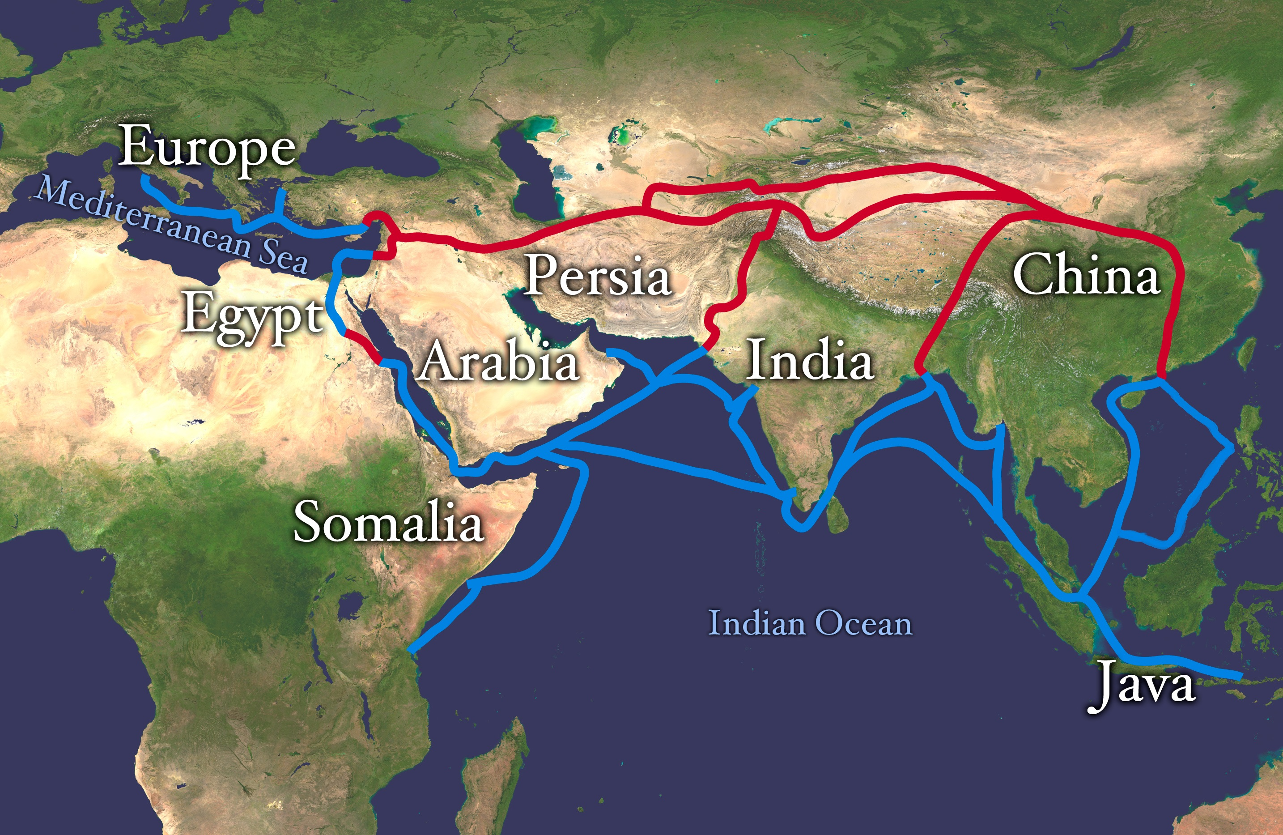

Silk Road Connecting Continents and Sea[2]

1. The land of Shu Brocade: “Shu” and Silk, and “Brocade” and “Embroidery”

The road research of anthropology, takes “things” as the carrier to explore the flow of ethnic groups and concepts in their mobile space as well as social and cultural changes.Then, it returns to its final goal, the study on human beings. The study of the South Silk Road have started from the Shu Brocade as the “object” and “Shu” land as the space.

**Chengdu: The Cultural Starting Point of the Southern Silk Road.** The “Silk Road” was originally a metaphor called by Westerns as the ancient China’s commercial and trade routes to overseas. Around the 2th Century B.C, the Greeks and Rome called China “Serice”, meaning “silk country”. “Silk” is an important symbol of Chinese civilization, and it is also one of the earliest images of the western world to understand China. Many Neolithic sites in China have silk weaving marks and remains, indicating the world’s silk weaving technology firstly appeared in China. It is noteworthy that the silk civilization originated in different regions of China among which Chengdu, known as the “land of abundance”, is the most important one. In the Book of Songs, there is a line, “the larvae of silkworm is “Shu”, and in the Origin of Chinese Characters, “Shu” character is explained as the development of the Silkworm, whose head is like the head of a “Shu” character, and its body also resembles the body of it. Furthermore, the name of “Shu” and “Shu Kingdom” is also related to the custom of planting mulberry and feeding silkworm in Sichuan.[3] The earliest ancestor of “Shu Kingdom” included 3 kings, Can Cong, Bo Guan, and Yu Fu, and 2 emperors, Du Yu and Kai Ming. Some scholars think the names of these five generations are all related to the evolution of cililization.[4] For example, “Can Cong” means thegathering of wild silkworms, which reflects the ability of the ancient Shu people who feeded the silkworm by eating and finding the function of wild silkworm.

In the Western Han Dynasty, the number of households in the capital Changan was 80800, while Chengdu has 76256 people, making it the second largest city following Changan. At that time, the business of Chengdu was quite prosperous, and its textile industry can reached to the world’s leading level. The writer of the Western Jin Dynasty, Zuo Si in his “Fu on Capital of Shu” also vividly described the prosperity of Chengdu’s business whose commodities were exported to the West as one of the most rich cities in the world at that time, The *Historical records. Biography of Da Wan,* recorded the report to Emperor Wudi by Zhang Qian after his first time to the western regions.

“When I saw bamboo stick and Shu cloth Daxia (near today’s Stan Balakh in Afghanistan), I asked people that where were they come from. The Daxia people said, “We businessmen go to the Shendu country which is in southeast of Daxia with the area of thousands of miles.Its locals are similar to the people in Daxia and it has a humid and hot whether. The soldiers there all fight by riding elephants and it is always hit by floods.”

Daxia is located in In the western Han, and people should go to the Han for thousands of miles. Today, the Shendu country lives from thousands of miles in southeast of Daxia which boasts Shu brocade so now it is not far away from Shu. Now we are preparing to visit Daxia in the way of Qiangzhong,which is relatively dangerous because the locals is not kind.

However, the Shaobei are controlled by the Huns, so it is best to follow the proper Road of Shu with no aggressors.”

Daxia called by Zhang Qian, was a Persian province which was conquered by the Rome empire. It can be seen that before the Western Han Dynasty, the objects of Shu like Qiong cane and Shu cloth had been introduced into the west on a “proper road” passing through India.

According to the documents from the pre-Qin period and present, there are still many “Silk Roads” from China to the Western Regions, and there are 2 generally recognized roads, north road and south road. [5]It is universally acknowledged in the historical records of the Han Dynasty and the historical theories of the Tang Dynasty that both 2 roads were opened by Emperor Wudi of the Han Dynasty after his ascension to the throne for 20 years and later were called as the “Silk Road”. After the Qin conquered the six countries, it opened the Jinniu Road and extended this Silk Road in the territory of China to the area of Shu, making it possible to sell local specialties to the outside region, bringing the culture of Shu into the Central Plains, and obtaining more connections through this “official road”. The multiple evidence of the existing documents and archaeological findings show that before Emperor Wudi opened the “Silk Road”, there was a trade road through Burma to India and West in the southwestern region opened by common people, which is just the “proper road” callded by Zhang Qian. Therefore, it can be found that at that time Chengdu had become a relatively independent economic and cultural hub which was not entirely dependent on the central authority, and directly connected with the “Silk Road” to the western regions.

**Shu Brocade: a cultural symbol on the South Silk Road.** What is “Shu cloth” Zhang Qian seeing sold by a businessman from Shendu country in the Daxia? Shu cloth is also known as “Huangrun fine fabric”, Sima Xiangru said in his *Fan Jiang Chapter*: “Huangrun fine fabric can make coat”, and Yang Xiong said in *Fu on Capital of Shu*: “Huangrun linen of one end (about 2 feet or 6 feet) is worth of several golds. “Some people regard this expensive “Huangrun fine fabric” was a kind of Shu linen fabric,while the others hold that it was a Shu silk fabric or Shu brocade. The Shu linen goods were commonly used by civilians in the 2th or 3th century B.C, so the merchants of Shu smuggled and sold out of the country by the Shu’s businessmen overcoming hardships from nature and society may be more precious than Shu silk fabrics. It is said that Shu Brocade was sold to the Empire of Rome at that time, making all the aristocratic women crazy. The emperor of Rome was afraid of the national degeneration for luxury and had to ban the purchase of Shu brocade. Bronze statues with fine patterns such as dragon pattern, return pattern and animal face pattern unearthed from Sanxingdui proved that there were dyed and embroidered embroidery and Brocade in Shu area 3000 years ago, which was later called Shu Brocade and Shu embroidery.

In the Qin and Han Dynasties, Shu brocade was comparable with Luo Qi in Qi and lu and the brocade in Xiangyi of Henan. During the period of Three Kingdoms, Shu brocade became an important economic source and military capital in Shu. Zhuge Liang said, “Today the people are poor and the country is weak, and the capital of defeating enemy only depends on brocade.” In Zuo Si’s *Fu on capital of Shu* s, there is a line” the brocade cleaned in the river is as beautiful as shell” ,which is also refers to the famous Shu brocade The Jinjiang River flowing through Shu is named for Shu brocade was washed here. The official office that managed brocade workshop is called “Brocade Administration City” on the bank of Jinjiang River, and the area where Brocade Administration City is located is called “Inner Brocade “, so Chengdu boasts the name of “Brocade City”.

It can be seen that the ancient Shu civilization bred by the Shu brocade as a symbol of the silk civilization, carrying unique wisdom and historical memory of clothing for thousands of years. Shu Brocade is regarded as the “Mother brocade in China”, and Shu area is the origin of Chinese silk civilization which has also become a geographical space and cultural starting point that should not be ignored in the silk road.

2. The Tour of Shu Brocade: Relevance and Historical ChangeBetween Objects and Roads

Through the investigation of Shu brocade and Shu area, people can see that the flow of things in space is the necessary prerequisite for the formation and connection of the roads. In addition, to research the changes and collisions of space, discourse and cultural concept caused by the circulation of Shu brocade is an important breakthrough for the anthropology study on South Silk Road.

**South Road: External Connection of the Agricultural and Commercial Society.** According to Zhang Qian, from Shu to the Daxia, a “proper road” from India has already been opened to sell the Shu products to the West. Archaeological evidence shows that the passageway from Shu to Central Asia through Yunnan, Myanmar, India and Pakistan may have existed during the Warring States Period. The barium-free glazed beads found in the early sarcophagus burials in Maowen area of Northwest Chengdu obviously came from Central Asia or West Asia. Rutile pith beads[6] unearthed from Tomb 24 of Warring States Period in Lijia mountain of Yunnan Province alsocame from West Asia. *Arthasastra of India* refers to the land of “cina”[7], which produces red and black silk, or black and white fabric. According to Mr.Rao Zongyi’s research, “cina” has the similar pronunciation with “Qin”, so it refers to Sichuan. After emperor Wudi learned that there was a “proper road” connecting Sichuan and India, he ordered Zhang Qian to take Shu county and Qianwei County as the stronghold and dispatch 4 secret envoys including Chu Ran and Chu Xi to explore the ancient road to India from four directions. This ancient road in history is the so-called “South Silk Road” today, and it is divided into three sections involving Sichuan-Yunnan, Yunnan-Burma, Burma-India sections. (details are in the following chart)

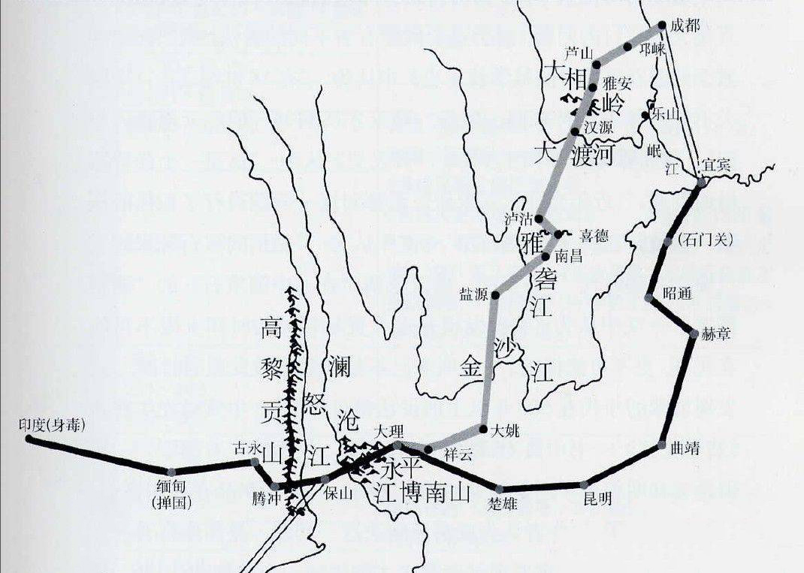

Main routes of the South Silk Road[8]

The name of “South Silk Road” is not derived from “the North Silk Road”, but because the transported commodity on this prosperous trade channel is silk, which has been opened for 150 to 200 years earlier than the”North Road”. The research of it has attracted the attention of the academic field since 1920s. In 1940s, it was paid attention for the construction of Yunnan-Burma and China-India highway that supported the war of resistance against Japan. In the 1980s and 1990s, especially since the Central Committee of communist Party of China called for “the reopening of the and North Silk Road “and “the development of western China”, the study ofthe South Silk Road reached its peak. Tong Enzheng, Ren Naiqiang and Jiang Yuxiang from the Department of history of Sichuan University has validated the origin and route of the “South Silk Road” from historical, archaeological and anthropological perspectives, which to some degree have turned out to be authoritative in academic field. Actually, Foreign sinologists had specialized studies on this. The French Sinologist Paul Pelliot and the author of “*Research on Two Roads*” believes that China and India had trade relations by Myanmar two centuries ago[9]. British scholar Gore E. Harvey in *The History of Myanmar[10]* also confirms that “Myanmar is adjacent to China, and since the 2nd century B.C., China has taken Myanmar as a commercial corridor. At the end of 19th Century, Richthofen, a German geologist, named the Road as “Silk Road” for silk trade between China- Central Asia and China-India from 114 B.C. to 127A.D. in China,which was quickly accepted and used by the academia and the public. Subsequently, in *The ancient Silk Road between China and Syria* published in the early 20th century written by the Hermann Hesse, a German historian, the range of silk road was further extended to the West Bank of the Mediterranean and Asia Minor according to the newly discovered archaeological materials. Its basic connotation was also determined, which refers to the continental trade starting from central Asia linking South Asia, West Asia, Europe and North Africa. For thousands of years, nomadic peoples or tribes, merchants, believers, diplomats, soldiers and academic observers have been moving around along the Silk Road. Regarding to the understanding of the “Silk Road”, it is necessary to reiterate it from two perspectives: external perspective and internal perspective. Before the west looking back to China’s “Silk Road”, the road network has been formed over the Eurasian continent, which not only includes the official channel “the northwest Silk Road” to western region opened by Zhang Qian in Western Han dynasty, and the “Grassland Silk Road” to the the West Asia through Mongolia plateau and the northern foot of Tianshan Mountain but also the rugged “Southwest Silk Road” from Changan through Chengdu to India , starting from Guangzhou, Quanzhou, Hangzhou, Yangzhou and other coastal cities, passing South China Sea to the Arabia Sea, even to the east coast of Africa and the “South Silk Road” as described above. From the perspective of anthropology, the so-called road traffic is the road network traffic between people and objects in the space, but not just refers to a certain historical stage of discourse. In addition, what should be noted is the official and the folk road. Beyond the Central area, the geopolitical center of the dynasty is not solely the political center. Excepting “official road”, there are a number of “folk road”, which has been developed by the civilians motivated by the economic and cultural factors. The South Silk Road is such an important one, and it has become an important external connection of the agricultural and commercial society at that time.

**West Region: Another Passageway** As mentioned above, the western part and the Shu area are also important parts of the overall picture of road network traffic beyond the political center of the Central Plains. The prosperity of Shu Brocade in a long history is a persuasive evidence. There are Two great leaps in the history of Shu brocade: the first one is that the nobility came to Shu after the Qin conquered the Six states, managing to combine the local weaving techniques of Shu with it in Central Plain. More bright and glazed brocade appeared, making its manufacturing place Chengdu soon replaced Xiangyi of Chen Liu as the weaving center of China. The second one is in the early Tang Dynasty when Dou Shilun, with Miliary lineage, came to Sichuan for Silk weaving supervision. He introduced the cultural elements of Western Regions and Persianl into Shu brocade weaving, creating a Lingyang Gong pattern which turned out to be the most popular brocade in the Tang Dynasty and had great influence on later generations. This two leaps of Shu Brocade should be attributed to the cultural integration triggered by road network traffic.

In October 1995, members of the Sino-Japanese Academic Investigation Team on Niya Site discovered a brocade protection clothing of Shu in the Han Dynasty in an ancient tomb at the Niya Site in Minfeng County, Hetian district, Xinjiang. The brocade had the words “five stars shining at the East is beneficial to China”, and it was praised as one of the greatest archaeological discoveries in China in the 20th century. This brocade reflects the Shu people’s recognition of the cultural unification of China at that time, and has the ability and consciousness to spread thoughts through the Silk Road.In a word,the brocade played an important role in spreading Chinese culture at that time.[11]

As the Japanese scholar Fujizawa Yimei pointed out: “When we talk about the way of cultural exchanges between East and West in Asian history, the so-called” Silk Road” in ancient times, we can generally cite two roads: the inland traffic road through Central Asia, and the southern maritime traffic roadopened up for the travel and transportation of Arab merchants after Tang dynasty. Little attention seems to be paid to the so-called “Yunnan-Burma Road” through Myanmar, Yunnan and Sichuan. Why is that so? The author thinks that there are two main reasons. On the one hand, the official history of traditional Chinese dynasty written in Chinese characters is accustomed to a narrative mode taking the kingdom in central plain as the center, covering the expression perspective of other regions and ethnic groups. Once the authoritative expression and narrative habits taking Central Plains as the center come into being, the West is easy to be “covered” in the historical expression and its spatial and historical importance connecting foreign countries also needs to be awakened and restated. On the other hand, in the historical facts, after the era of navigation, the space channel of East-West communication changed from continent to sea, and the continental transportation center in the West also shifted to the eastern coast, thus the Shu brocade declined. In the Ming Dynasty, the consumption and export of Shu brocade were greatly affected by the sale of Dongyang cotton introduced into China by the sea. In the Qing Dynasty, the tense situation of internal blockade and foreign invasion made Shu brocade almost withdraw from the commercial market.

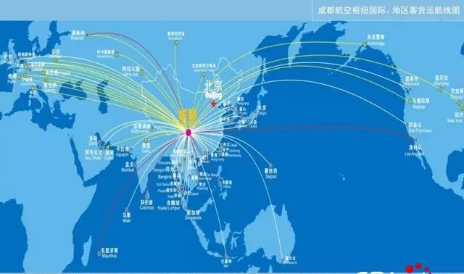

International and regional passenger and cargo routes for Chengdu Airlines hub in 2017[12]

On September 7 of 2013, Chinese President Xi Jinping delivered an important speech entitled “Promoting Friendship of People for a Better Future”at Tanner Zalba Jef University in Kazakhstan, calling for that people of all countries along the way jointly build the “Silk Road Economic Belt”. This is aspeech that the “Silk Road” has been revived by official political discourse, and it is ready to be paid attention in a new round of discussion. This kind of discussion mainly lies in breaking the binary opposition between the East and the West, China and other countries, the central plains and the west,as well as the gap between the internal and external research of the “Silk Road”. Taking Chengdu as an example, the “west” and “Shu” which were shaded by the “Central Plains” in history are no longer a declining geographical center, but become a hub of world economic and cultural exchanges under the background of modern road network traffic again. As president Xi Jinping said in the “One Belt and One Road” initiative, we hope that the establishment of a new type of national cooperative area is based on the principle of co-operation, co-construction and sharing. We should work hand in hand to meet the challenges threatening the world economy and continue to move forward to the community of common destiny of mankind. There are so many such cities and regions, no matter in the Central Plains or the West and in China or the West. The modern transportation network has been connected in all directions In the reality of economic and cultural globalization and under the new discourse of sharing community of human destiny.

3. Changes in Shu Brocade: New Shu Brocade and New Silk Road

As mentioned earlier, the study of the relationship between Shu brocade and the Southern Silk Road reveals that the roads can be instructed and communicated with the flow of objects, but the cultural significance carried by them can be obscured in the historical discourse. The change of such concept and discourse is what anthropology should pay special attention to in the overall study on the road. It will also be more prominent in the diachronic study, making the road of anthropology research refreshed with new academic value and practical significance.

**Shu handicraft: The Ancient and Modern Heritage of the Folk World**

After the Tang Dynasty, due to the wars in the Song and Yuan Dynasties, the Silk Road was mostly blocked by the Huns. At this time, shipbuilding skill improved with the sea silk road opened gradually replaced the continental silk road,and make the commercial and trade center shifted from inland to coastal areas. The thousand-year warp-knitting technology represented by Shu brocade was replaced by the mechanized production with simple operation, variety and higher efficiency. By the Opium War, foreign goods flooded the domestic market, national industries were severely shocked, and Shu brocade handicraft industry lost its advantage. On the eve of the founding of People’s Republic of China, the production and sale of Shu Brocade showed even moredepression. In order to save the dying Shu brocade, in the early 1950s, a small number of Shu brocade craftsmen raised funds to set up a Shu Brocade Factory in the thatched cottage of the ancestral temple on Wangxian field Street in Chengdu. It is said that Zhu De visited the Shu Brocade Factory in Chengdu twice and instructed the Municipal Secretary of the Communist Party of China, Wang Zhen, to allocate special funds to improve the the factory’s production conditions. In the early 1960s, the Shu brocade technique was innovated. The original man-made wooden loom with hand-pulled flower, hand shuttle and foot-tread machine were replaced by the electric iron-wood floral loom working by collective transmission, and then it developed into the all-iron floral loom working by single-machine transmission. The variety, yield and quality of Shu brocade have been greatly improved, and the traditional weaving techniques have been well protected and inherited. After the reform and opening up, a new generation of designers have systematically excavated and collated the patterns of Shu brocade,so Shu Brocade Factory resumed large-scale production again, with 505 looms and an annual output value of nearly 100 million RMB.

In the process of globalization, the rebirth of Shu brocade and its weavingtechnology is not only to return to the market as a commodity, but also to be protected and inherited as an intangible cultural heritage. The traditional Shu brocade weaving technique is a silk weaving technique with a long history. Its technique inheritance relies on face-face instruction. Only in the long-term accumulation can apprentices master the usage of the Hualou loom.[13]By the end of the 1990s, the production of Shu brocade was sharply reduced due to the lack of core technicians. In 2006, Shu brocade weaving technology was approved by the State Council and listed in the first batch of national intangible cultural heritage list. In 2010, the silk weaving technique in Chengdu was listed on the list of intangible cultural heritage by UNESCO.

With the increasing mention and attention of cultural diversity, the ancient Shu brocade weaving technology not only changes and innovates with the changes of historical conditions, but also be given a new sense of recognition and history as the common historical memory of mankind from the perspective of intangible cultural heritage.

**Capital Shu: The contemporary Changes of Silk Language**

In addition to the inheritance of skills, the Shu brocade also have changed into a political, economic and cultural symbol of a city and place with unique connotations in modern society. In 2003, Chengdu Shu brocade Factory merged into Chengdu Shu brocade Cultural Development Co., Ltd. The former site of Chengdu Shu brocade Factory was transformed into a tourist shopping complex named Shujiang Brocade Courtyard, which became a space for Shu brocade culture exhibition and artistic performance endowed with new cultural and commercial values. It is located in a famous street named “Inner Brocade “beside the Wuhou Temple in Chengdu, taking the style of dwellingsin the late Ming and early Qing dynasties of Western Sichuan as its architectural style and containing the culture of the Three Kingdoms and Chengdu folklore, it has become a famous tourist destination. In 2012, four models of bamboo-wood looms soaked in water were unearthed from a cemetery of Western Han Dynasty in Laoguan mountain of Tianhui Town in Chengdu, which became an important historical object for the inheritance and study of Shu brocade. The place where jacquard loom was unearthed, Jinmen, was built as the starting point of the South Silk Road by tourism and commerce. This is a small tourist town of silk commerce integrating culture, tourism, shopping, delicacies and leisure. At the end of 2017, the Chengdu Museum, located in the center of Chengdu, exhibited Shu brocade together with Song brocade, Yunbrocade and Zhuang brocade in the Chinese Brocade Culture Exhibition, and emphasized its historical status as “the mother brocade of the world” and “the origin of the ten thousand brocades” to declare that Shubrocade boasts an irreplaceable cultural identity in modern Chengdu.

Rain in Hibiscus city in March falls heavily and falls like needles in April Feather fan points to thousands of military and brocade was cut into several inches.

The theme song of the Chengdu Intangible Cultural Heritage Festival, Shu Embroidery, composed by Guo Jingmin and sung by Li Yuchun, is now popular among modern young people. It spreads the “splendor” of the Shu and the ancient meaning of the city to modern people by processed and innovated modern culture. Just as the Silk Road has been reborn under the background of economic globalization and the discourse of the community of shared destiny of mankind, Shu embroidery and the capital Shu, where it is located, have been constantly discussed and expressed in the process of Urbanization. Therefore, the old handicraft and memories have been injecting new cultural meanings.

Road Heritage: the Road of Objects and the Study of Road

In the physical space of human communication, objects and roads are necessarily related. By investigating the relationship and historical changes between Shu brocade and objects on South Silk Road, we can see that the exchange of objects has made the road accessible and it also changed with the function of road network traffic. The connection between things and roads lies more in the role of human beings, especially in the shaping by the human concepts. Objects and roads actually are the products of human’s existence and interaction in the world. Anthropological study on the road heritage is actually taking the relevant roads and objects as the living world of human beings to be observe and paying particular attention to the interactive relationship between people -objects and people-roads as well as their evolution.

Anthropology has a tradition of deep research on “objects”. It began with the study of archaeological anthropology which took things as the symbol of cultural evolution by Morgan and followed by the study of structural anthropology ,symbolic anthropology and semiotic anthropology, which took things as cultural symbols and meaning systems. There are also a group of scholars who regard objects as the motive force of social change and the study object of tangible cultural heritage. All of the studies are mainly based on the anthropological investigation on objects and the ethnographic writing on objects to describe and explain human life and cultural landscape.

Then, as a kind of research related to objects, road research also aims at presenting different social and cultural forms as a special and stable space derived from the development and changes of people’s concepts. Emile Durkheim pointed out the complexity of road as a man-made object, and studied the relationship between space instruction and social power. He believes that space is a social construct, and its “emotional value, spatial classification and other social attributes belong to society”[14]. Michel Foucault uses discourse theory to explain space, and regards it as the basis of the operation of spatial power, which is”not only the eye of power, but also the carrier of all powers to realize their functions”.[15] Chinese anthropologists have studied the “Ethnic Corridor” from Fei Xiaotong, Shi Shuo, Li Shaoming and so on, who taken the road study as an important supplement for previous village studies. Some scholars also put forward relevant academic concepts and theoretical frameworks such as “Road Study”.

The purpose of this paper is to re-examine the “margin” covered by discourse and power centers in the overall study of the Silk Road, and to study Shu Brocade, the road heritage on Southern Silk Road from an anthropological perspective, so as to extend road network traffic to make it connect with larger space-time, ethnic groups and cultural patterns to see the overall change of the human road, and obtain a more comprehensive view of human culture. Therefore, the author believes that the anthropological concern and research on the road heritage actually contains two important parts:

One is the holistic study of human changes in time and space, that is the study of changes and trends in the past, present and future of human civilization as a whole. The another one is the study of human interaction in time and space, that is the study of the interaction between different ethnic groups and civilizations with the road heritage as the space carrier. The former started with Morgan, other early evolutionists and scholars voting for communication theory, and then archaeological anthropology, biological anthropology and molecular anthropology have been elucidating and basically obtaining the authority of discourse. The anthropology above is mainly paid attention by cultural anthropology, which focuses on ethnic communication and cultural diversity, and emphasizes the study of connectivity and interaction beyond the fixed-point field of modern anthropology and the classical paradigm focusing on ethnography. The main purpose of this kind of road heritage research is to break the inherent boundaries between ethnic groups and culture to present a more dynamic and panoramic human road landscape and its cultural patterns by taking the “road” as the object of study and linking the opposite self, the other, the theme and the object in the classical paradigm.

Road, with a special connection function, not only links the human ethic groups and their cultures in different space, but also carries the changes of human beings and their civilizations in the sense of time. This characteristic is precisely what anthropology concerning about ethnic exchanges and changes of human civilization should study. It can be said that the study of anthropology is also the study of the human road. In today’s interconnected modern civilized world, the study of road heritage will definitely gain new theoretical value and practical significance in the road research of anthropology.

Reference:

[1] Sima Qian. Shiji [M].: Zhonghua Book Company, 1959.

[2] Ren Naiqiang. A Series of Books on the History of Ba and Shu. A New Exploration of the Ancient History of Sichuan. Sichuan People’s Publishing House. 1986.

[3] Gu Jiegang. On the relationship between Ba and Shu Region and Central Plains. [M]. Sichuan People’s Publishing House.1981.

[4] Ren Naiqiang. Notes on records of Southern China [M]. Shanghai Ancient Book Publishing House.1987.

[5] Tan Jihe. Ba and Shu Culture Thoughts Collection [M]. Sichuan People’s Publishing House.2004.

[6] (France)by Paul Pelliot and translated by Feng Chengjun. Zheng He’s Ocean Research.Research of Two Roads[M]. Beijing: China Book Company. 2003.

[7] (English) by Ge E. Harvey, translated by Yao Ziliang. History of Myanmar [M]. Beijing: Commercial Press. 1973.

[8] (France)by Emil Durkheim, translated by Qudong, Ji Zhe. Basic Forms of Religious Life [M]. Shanghai People’s Publishing House. 1999.

[9] (France) Michelle Foucault, translated by Yan Feng: An Interview with Foucault: The Eye of Power [M]. Shanghai People’s Publishing House. 1997.

[10] Zhao Xudong. A New Extension of the Concept of “One Belt and One Road” to the Study of Anthropology Civilization. [J], Ideological Front, No.1, 2016.

[11] Zhou Enyu. Anthropological Framework for Road Research [J], Journal of Beifang University of Nationalities, No. 3, 2016.

[12] Ma Zhen. The Concept Change of “Objects” in Anthropological Research [J], Journal of Guizhou University (Social Science Edition), Vol. 33, No. 5.

1. The 16th High-level Forum on Anthropology was held in Xining City, Qinghai Province, from August 4 to 6, 2007. The theme was “Road and Ethnic Groups”. Mr. Huang Shumin, an anthropologist and former chairman of the Department of Anthropology at Iowa State University and a researcher and director of the Institute of Ethnology in Academia Sinica in Taiwan was invited to attend and deliver a speech.
2. 3 Source of picture：[https://upload.wikimedia.org/wikipedia/commons/7/74/Silk_route.jpg](https://upload.wikimedia.org/wikipedia/commons/7/74/Silk_route.jpg。)
3. *Can Cong Research* written byRen Naiqiang, the author believes that “Shu character origins from silkworm”, “So the ancient Shu characters whose shape likes a silkworm with giant eyes were specially made for the silkworm. The 220th pages of *the notes of Southwest records of* 1987 edition written by Mr. Ren Naiqiangand printed by Shanghai ancient book publisher, can be referred.
4. *The Present and Future of Study on Ba and Shu Culture written by* Tan Jihe maintains that the name of ancestors of Shu” refers to the life style Shu People’s life style Shu People in five times of economic agriculture: Can Cong is characterized by silkworm, which is the era of collection; the time of Bo Guan time is a hunting age,; and the time of Yu Fu is… the age of fishing, hunting and herding; Du Yu also name “host of land” who encourage people to farm and the agriculture was invented in his time... and the time of Kai Ming reached to the peak of urban civilization and entered the era of production economy. The page 53-54 of Thoughts Collection of Ba and Shu Culture *of* 2004 edition written by Mr. Ren Naiqiangand printed by Sichuan people’s publisher, can be referred.
5. The North Road runs westward along the Ili River Valley to the north of the Tianshan Mountains, through Central and Western Asia, and the south of the Tianshan Mountains into the Europe, westward along the Tarim River valley, west of Shule ( Kashgar) and across the Yuancong Mountains (Pamir Plateau) through Central Asia into the Europe.
6. Gao Zhixi: *On China’s Glassware in the Spring and Autumn Period and the Warring States Period and Related Issues*, published in *Cultural Relics*, No. 12, 1985, PP. 54-56.
7. Rao Zongyi, S*hu cloth and cinapatta - On the Early Traffic between China, India and Myanmar*, 45 copies from the *Collection of Institute of Historical Language* (Taiwan), 1974, PP. 561-584.
8. photo source: <http://blog.sina.com.cn/s/blog_8888506e010195xn.html>
9. [France] *Zheng He’s Western research, research on two roads:* by Paul Pelliot and translated by Feng Chengjun,2003 edition of China Book Company.
10. [English] *History of Myanmar,*by Ge E. Harvey and translated by Yao Ziliang, June 1973, Business Press, P 368.
11. Tan Jihe, *The Origin of Ancient Shu Civilization and Tianfu Silk*, from *Chinese Culture Forum*, No. 4, 2017.
12. Photo source: http://www.cet.com.cn/dfpd/jzz/sc/sc/1658042.shtml
13. According to Hu Guangjun, a representative inheritor of Shu brocade weaving skills and former director of the Institute of Ancient Shu Brocade, who visited the Center for Co-development and Innovation of Multi-Ethnic Literature of Sichuan University in June 2017, it took a long time to learn Shu brocade, and it took five to six years to learn its basic operation. The first three months can not touch the loom, can only blindly practice the knotting of silk thread, three months later began to learn the flower-pulling, shuttle-throwing style... Three years out of school, five years out of work, weaving a section of brocade, generally through weaving flower pattern, using shuttle and other ten processes, brocade is no more than 10 cm weaved in a day .
14. [France] Emil Durkheim. *Basic Forms of Religious Life* [M]. Qudong, Jizhe, Translation. Shanghai: Shanghai People’s Publishing House, 1999.
15. Michel Foucault *Foucault Interview: The Eye of Power* [M]. Yan Feng, Trans. Shanghai: Shanghai People’s Publishing House, 1997.